[CREATE](http://localhost/phpmyadmin/url.php?url=https://dev.mysql.com/doc/refman/5.5/en/create-table.html) [TABLE](http://localhost/phpmyadmin/url.php?url=https://dev.mysql.com/doc/refman/5.5/en/create-table.html) `stock`.`buy` ( `i_id` [VARCHAR](http://localhost/phpmyadmin/url.php?url=https://dev.mysql.com/doc/refman/5.5/en/string-types.html)(25) [NOT](http://localhost/phpmyadmin/url.php?url=https://dev.mysql.com/doc/refman/5.5/en/logical-operators.html#operator_not) NULL , `i_name` [TEXT](http://localhost/phpmyadmin/url.php?url=https://dev.mysql.com/doc/refman/5.5/en/string-types.html) [NOT](http://localhost/phpmyadmin/url.php?url=https://dev.mysql.com/doc/refman/5.5/en/logical-operators.html#operator_not) NULL , `i_type` [TEXT](http://localhost/phpmyadmin/url.php?url=https://dev.mysql.com/doc/refman/5.5/en/string-types.html) [NOT](http://localhost/phpmyadmin/url.php?url=https://dev.mysql.com/doc/refman/5.5/en/logical-operators.html#operator_not) NULL , `i_price` [INT](http://localhost/phpmyadmin/url.php?url=https://dev.mysql.com/doc/refman/5.5/en/numeric-types.html)(5) [NOT](http://localhost/phpmyadmin/url.php?url=https://dev.mysql.com/doc/refman/5.5/en/logical-operators.html#operator_not) NULL , `i_qty` [INT](http://localhost/phpmyadmin/url.php?url=https://dev.mysql.com/doc/refman/5.5/en/numeric-types.html)(10) [NOT](http://localhost/phpmyadmin/url.php?url=https://dev.mysql.com/doc/refman/5.5/en/logical-operators.html#operator_not) NULL , `i_order_date` [DATE](http://localhost/phpmyadmin/url.php?url=https://dev.mysql.com/doc/refman/5.5/en/date-and-time-types.html) [NOT](http://localhost/phpmyadmin/url.php?url=https://dev.mysql.com/doc/refman/5.5/en/logical-operators.html#operator_not) NULL , `i_receive_date` [DATE](http://localhost/phpmyadmin/url.php?url=https://dev.mysql.com/doc/refman/5.5/en/date-and-time-types.html) [NOT](http://localhost/phpmyadmin/url.php?url=https://dev.mysql.com/doc/refman/5.5/en/logical-operators.html#operator_not) NULL , `i_suplier_id` [VARCHAR](http://localhost/phpmyadmin/url.php?url=https://dev.mysql.com/doc/refman/5.5/en/string-types.html)(20) [NOT](http://localhost/phpmyadmin/url.php?url=https://dev.mysql.com/doc/refman/5.5/en/logical-operators.html#operator_not) NULL , `i_suplier_contact` [INT](http://localhost/phpmyadmin/url.php?url=https://dev.mysql.com/doc/refman/5.5/en/numeric-types.html)(15) [NOT](http://localhost/phpmyadmin/url.php?url=https://dev.mysql.com/doc/refman/5.5/en/logical-operators.html#operator_not) NULL , PRIMARY KEY (`i_id`(25))) ENGINE = InnoDB;

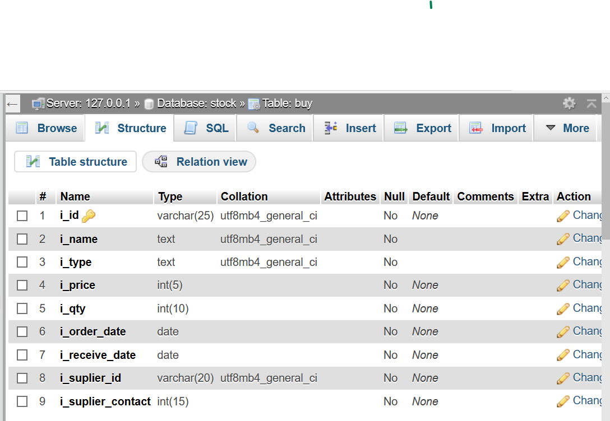

[CREATE](http://localhost/phpmyadmin/url.php?url=https://dev.mysql.com/doc/refman/5.5/en/create-table.html) [TABLE](http://localhost/phpmyadmin/url.php?url=https://dev.mysql.com/doc/refman/5.5/en/create-table.html) `stock`.`sell` ( `i_id` [VARCHAR](http://localhost/phpmyadmin/url.php?url=https://dev.mysql.com/doc/refman/5.5/en/string-types.html)(25) [NOT](http://localhost/phpmyadmin/url.php?url=https://dev.mysql.com/doc/refman/5.5/en/logical-operators.html#operator_not) NULL , `i_name` [TEXT](http://localhost/phpmyadmin/url.php?url=https://dev.mysql.com/doc/refman/5.5/en/string-types.html) [NOT](http://localhost/phpmyadmin/url.php?url=https://dev.mysql.com/doc/refman/5.5/en/logical-operators.html#operator_not) NULL , `sell_price` [INT](http://localhost/phpmyadmin/url.php?url=https://dev.mysql.com/doc/refman/5.5/en/numeric-types.html)(20) [NOT](http://localhost/phpmyadmin/url.php?url=https://dev.mysql.com/doc/refman/5.5/en/logical-operators.html#operator_not) NULL , `sell_qty` [INT](http://localhost/phpmyadmin/url.php?url=https://dev.mysql.com/doc/refman/5.5/en/numeric-types.html)(20) [NOT](http://localhost/phpmyadmin/url.php?url=https://dev.mysql.com/doc/refman/5.5/en/logical-operators.html#operator_not) NULL , `sell_date` [DATE](http://localhost/phpmyadmin/url.php?url=https://dev.mysql.com/doc/refman/5.5/en/date-and-time-types.html) [NOT](http://localhost/phpmyadmin/url.php?url=https://dev.mysql.com/doc/refman/5.5/en/logical-operators.html#operator_not) NULL , `sell_id` varchar(20) [NOT](http://localhost/phpmyadmin/url.php?url=https://dev.mysql.com/doc/refman/5.5/en/logical-operators.html#operator_not) NULL, primary key(sell_id (25))) ENGINE = InnoDB;

[ALTER](http://localhost/phpmyadmin/url.php?url=https://dev.mysql.com/doc/refman/5.5/en/alter-table.html) [TABLE](http://localhost/phpmyadmin/url.php?url=https://dev.mysql.com/doc/refman/5.5/en/alter-table.html) `sell` ADD FOREIGN KEY (`i_id`) REFERENCES `buy`(`i_id`) ON [DELETE](http://localhost/phpmyadmin/url.php?url=https://dev.mysql.com/doc/refman/5.5/en/delete.html) RESTRICT ON [UPDATE](http://localhost/phpmyadmin/url.php?url=https://dev.mysql.com/doc/refman/5.5/en/update.html) RESTRICT;

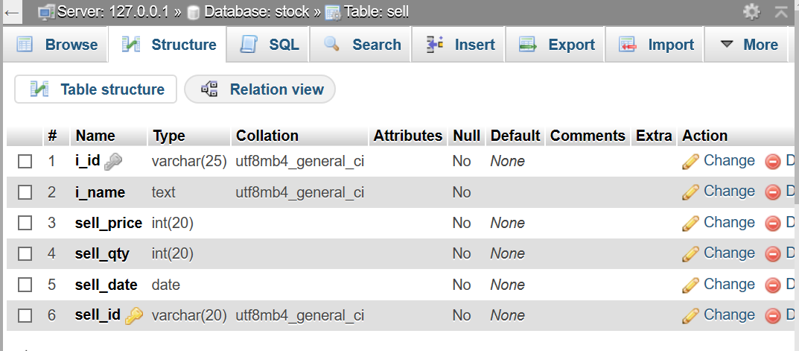

[CREATE](http://localhost/phpmyadmin/url.php?url=https://dev.mysql.com/doc/refman/5.5/en/create-table.html) [TABLE](http://localhost/phpmyadmin/url.php?url=https://dev.mysql.com/doc/refman/5.5/en/create-table.html) `stock`.`demage` ( `sell_id` [VARCHAR](http://localhost/phpmyadmin/url.php?url=https://dev.mysql.com/doc/refman/5.5/en/string-types.html)(20) [NOT](http://localhost/phpmyadmin/url.php?url=https://dev.mysql.com/doc/refman/5.5/en/logical-operators.html#operator_not) NULL , `detail` [TEXT](http://localhost/phpmyadmin/url.php?url=https://dev.mysql.com/doc/refman/5.5/en/string-types.html) [NOT](http://localhost/phpmyadmin/url.php?url=https://dev.mysql.com/doc/refman/5.5/en/logical-operators.html#operator_not) NULL , `sell_date` [DATE](http://localhost/phpmyadmin/url.php?url=https://dev.mysql.com/doc/refman/5.5/en/date-and-time-types.html) [NOT](http://localhost/phpmyadmin/url.php?url=https://dev.mysql.com/doc/refman/5.5/en/logical-operators.html#operator_not) NULL , `return_date` [DATE](http://localhost/phpmyadmin/url.php?url=https://dev.mysql.com/doc/refman/5.5/en/date-and-time-types.html) [NOT](http://localhost/phpmyadmin/url.php?url=https://dev.mysql.com/doc/refman/5.5/en/logical-operators.html#operator_not) NULL , `return_qty` [INT](http://localhost/phpmyadmin/url.php?url=https://dev.mysql.com/doc/refman/5.5/en/numeric-types.html) [NOT](http://localhost/phpmyadmin/url.php?url=https://dev.mysql.com/doc/refman/5.5/en/logical-operators.html#operator_not) NULL ) ENGINE = InnoDB;

[ALTER](http://localhost/phpmyadmin/url.php?url=https://dev.mysql.com/doc/refman/5.5/en/alter-table.html) [TABLE](http://localhost/phpmyadmin/url.php?url=https://dev.mysql.com/doc/refman/5.5/en/alter-table.html) `demage` ADD FOREIGN KEY (`sell_id`) REFERENCES `sell`(`sell_id`) ON [DELETE](http://localhost/phpmyadmin/url.php?url=https://dev.mysql.com/doc/refman/5.5/en/delete.html) RESTRICT ON [UPDATE](http://localhost/phpmyadmin/url.php?url=https://dev.mysql.com/doc/refman/5.5/en/update.html) RESTRICT;

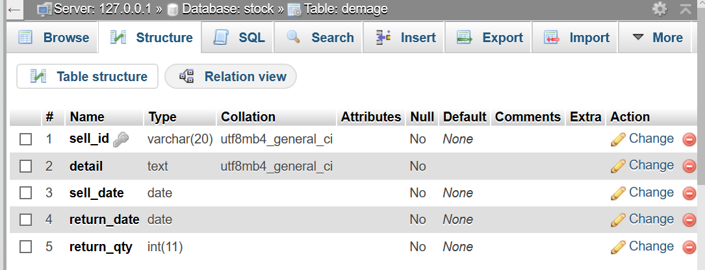

Data Dictonary

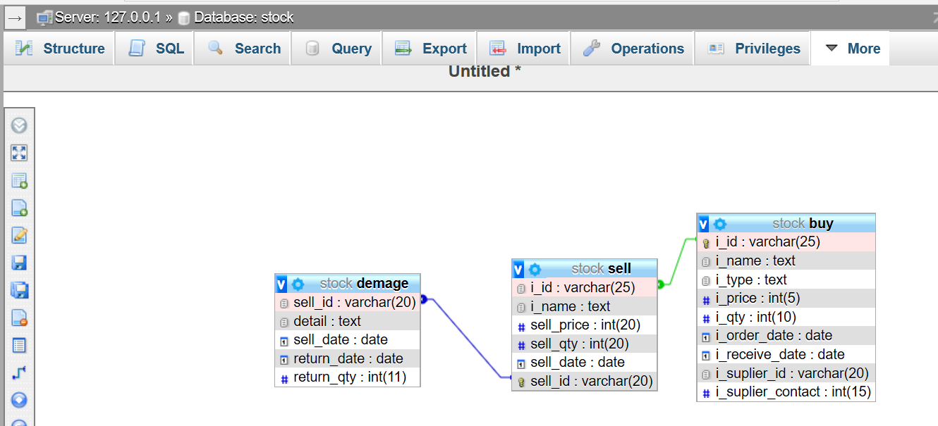

ER DIAGRAM:-

